TATSFIELD ALLOTMENTS AND COMMUNITY GARDENS

A brief history
Tatsfield is a village with approximately 1700 inhabitants located in the Tandridge district of Surrey, England, 16 miles south of London, on the border between Kent, Surrey and London. The village is situated on the top of the North Downs, at an altitude of 750 feet, within the “green belt”area. It is a relatively isolated village, with limited local transport links, which engenders a strong sense of community spirit and self reliance.
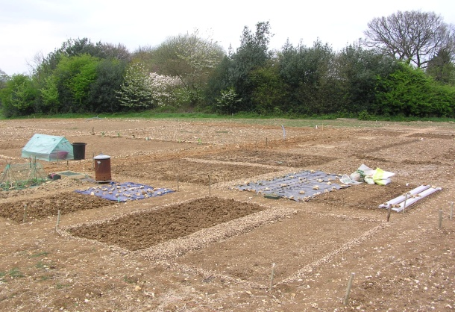
In common with many parts of the country, the local authority has a shortage of allotment sites in the area and there are long waiting lists for a plot to become available on one of the existing sites. In September 2009, a survey form was sent out to the 700 households within the parish of Tatsfield to determine whether there was sufficient interest from local residents and organisations to establish an allotment and community garden scheme; of the 700 circulated, over 50 responded expressing an interest in joining such a scheme. In November 2009, a public meeting was held in the village’s Parish Rooms to discuss the idea further. The conclusion from the meeting was that there was both a need and a desire for such a scheme and, shortly after, firm commitments were received from 56 households. Throughout the consultation process, the local population were kept informed of progress by the regular articles reported in the monthly Parish magazine.
During the remainder of 2009, a search was undertaken to find a suitable plot of land. In summer 2010, a local farmer, Mr. John Whelan of Whelan Farms Ltd, agreed to lease a triangular plot of level land with suitable access for a 25 year period, to the Parish Council. The Parish Council have, in turn, sub let the plot to the Tatsfield Horticultural Society who oversee the operation and management of the scheme.
The Tatsfield Horticultural Society, established in March 1972, is a voluntary organisation whose objective is to promote knowledge and interest in horticulture, conservation, ecology and the environment for the benefit and well being of the local community. The Society has a membership comprising 355 households (i.e. approximately 40% of the village) and has a committee of 14 volunteers with a president, chairman, secretary, and treasurer who meet regularly throughout the year. The committee have appointed a Tatsfield Allotments and Community Gardens sub committee who have responsibility for running the scheme, on a day-to-day basis.
In January 2011 access was gained to the site and the boundaries agreed. The open site, measuring 0.73 hectares (1.81 acres), is situated on the western fringe of the village, and has Approach Road (one of two main roads accessing the village) as it’s southern boundary with a natural country hedge with large gaps. The northern edge of the site, with its open boundary, borders the farmer’s field which is currently used for growing arable crops. The eastern boundary is adjacent to the rear garden of a residential dwelling and has a mixed hedgerow. All three boundaries are currently accessible by all and not considered to be secure. To provide security from theft and damage by deer and rabbits, a 1.9m high perimeter fence is required and an application for grant funding of this project has been made to the Big Lottery Fund. Additional protection is needed from the South Westerly winds and a country hedge will be planted on the farmer’s side of the fence together with a 6 metre grass buffer zone.
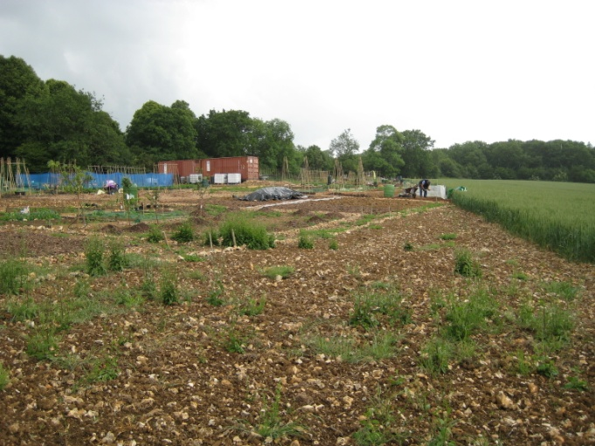
In March 2011, the water pipes were laid and the individual plots marked out and allocated; there are currently 36 large plots (measuring 100m²), 12 half plots (measuring 50m²) and 24 starter plots (measuring 16m²), totalling 72 plots. All plots are currently occupied by local groups and residents and there is a waiting list of people wishing to rent a plot as and when one becomes available. Free plots were offered to the local Scout group and pre school nursery, and smaller, starter plots are available for those who prefer a smaller space. Two second hand shipping containers were purchased and positioned on the site, to provide a covered shelter for people to meet and congregate, and a place to securely store equipment. The central area of the site, (surrounding these shelters), has been reserved for the creation of a community garden and composting area. In Autumn 2011, the award winning Tatsfield Community Composting Scheme moved to the site; new compost bins are being constructed to facilitate an increase in production of the compost known locally as “black gold”. The community garden will be a grassed area where all members of the community can gather to socialise, communicate and enjoy the far reaching views. It is envisaged that this area, which will be furnished with seating and raised beds will also be used for teaching and demonstration sessions, and for social functions such as barbeques and family days.
In April 2011, permission was received from Surrey County Council, Highways division, to create a vehicular entrance to the site from Approach Road. The committee hired a digger and, using voluntary labour, created a temporary hard standing area to accommodate delivery vehicles and allow access for people with restricted mobility. Local organisations were persuaded to contribute in various ways; builders donated advice and materials, professional horticulturalists provided practical advice, mechanics assisted with the use of their rotavator, local stables provide a constant supply of manure and the local arboriculturalist supplies the site with wood chippings.
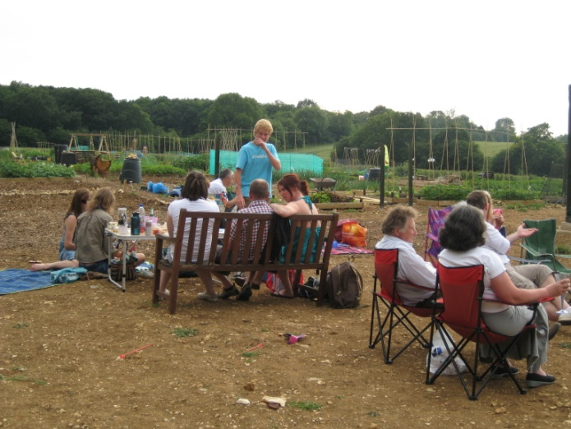
Plots are now being worked on by enthusiastic plot holders and, as we approach the end of our first growing season, the ground has proved to be fertile and productive. The overwhelming community spirit has resulted in working parties giving up their time to paint the storage containers, lay water pipes and install water butts throughout the site and undertake many other improvements. In July 2011, a barbeque was held at the site to which the whole community were invited; it provided an opportunity for all members of the community to meet, socialise and exchange ideas whilst enjoying the produce grown and promoting healthy eating and an awareness of where food has come from. The site was visited by the South and South East in Bloom judges in July 2011 and awarded a special commendation.
In September 2011, the “Big Lottery Fund – Awards for All” awarded the Scheme a conditional grant to erect a boundary fence, with a pedestrian gate, around the perimeter of the site, to protect the site from vandalism and theft and to exclude wild animals. This fence will also ensure that young children and vulnerable adults cannot stray onto the adjacent road and will protect the site from flying debris from the neighbouring farm’s machinery. In October 2011, a grant was received from Surrey County Council for the installation of pitched roofs over the two containers, to facilitate the collection and storage of rainwater. Further good news followed in February 2012 when Surrey Hills Leader awarded a grant for the creation of a hard surface pathway, to run the length of the site, which is suitable for wheelchair users, mobility scooters and buggies and will ensure that the site is accessible by all members of the community, including those with limited mobility and users of the community composting scheme. In March 2012 we were delighted to be awarded a grant from Community Foundation for Surrey to install seating and raised beds in the community garden, and to expand the community composting facility; these facilities will ensure that all ages can participate fully in the delights of gardening and caring for the environment. Financial support has also been received from Tandridge District Council, Tatsfield Parish Council and the “community matters” scheme sponsored by Waitrose.
The community are extremely grateful for the financial assistance received to date; most projects have now been completed though work is yet to be undertaken to community garden area. The success of the Scheme thus far has been due to the huge voluntary input from members of the community; the composting team have managed the move from their old site in Borough Road to the new site and have been busy building new compost bins and shredding material to convert into compost known locally as “black gold”; the site has received free regular deliveries of horse manure and wood chippings from the local stables and arbouriculturalist; numerous hours have been spent by volunteers to develop and maintain the site, and by the committee to ensure the smooth running of the Scheme. Many people have commented on how much has been achieved in just a year.
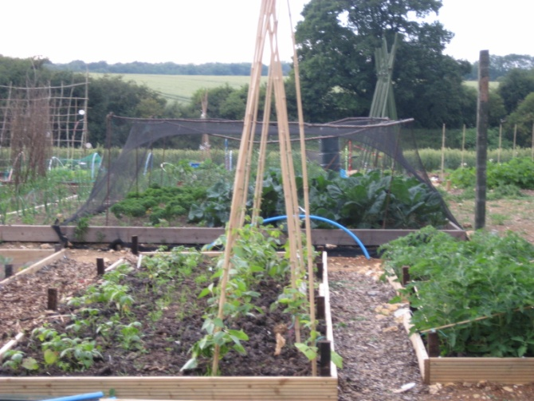
The committee do not intend to “rest on their laurels” and have lots of ideas for the further development of the site, finances allowing. The plot holders pay an annual rent for the use of their plots plus a contribution towards the use of certain shared facilities such as water, but the further development of the communal facility requires additional funds to be secured from further grants or fund raising activities.

Plans for the further development of the site include:-
- Arranging demonstrations and talks (to be given by our resident professional horticultural experts) whereby all sectors of the community will have the opportunity to learn about aspects of horticulture, conservation, healthy eating, ecology and the environment.
- Developing the community garden to provide a space where lonely and isolated members of the community can be included in social activities; where parents can spend time with their children enjoying the delights of growing and eating, whilst providing a safe place for children to play and discover nature; where elderly and less able people can sit and chat, enjoying the wonderful views across South London; where disengaged young people can develop a sense of pride in their local community which will help prevent anti social behaviour; where working people can relax from the stress of work and make new friends; where the unemployed can feel useful and included with access to fresh produce at minimal cost; where all can access and enjoy the beauty of the surrounding countryside and observe wildlife.

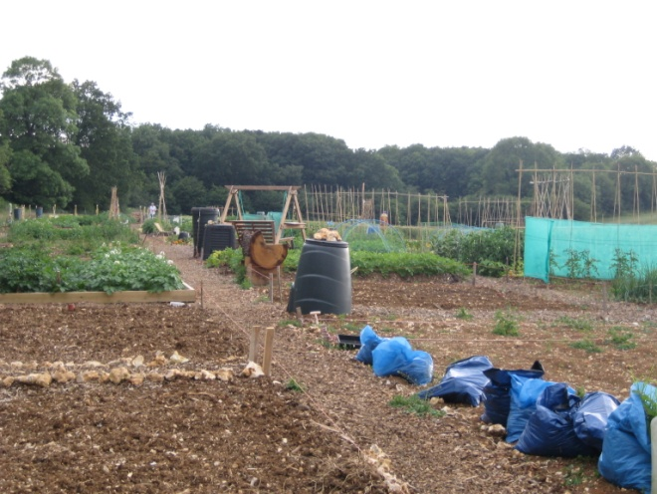
- Installing an underground rainwater storage tank, such that rainwater can be collected and stored, to reduce the dependence on mains water usage and to promote sustainability and an awareness of the environment and its precious resources.

- Installing an electricity supply that will be used to power the pumping of rainwater from the underground storage tank to the 10 above ground water tanks. The supply will also enable us to install security lighting, CCTV equipment, and power sockets and lighting inside in the containers.

We will continue to ensure that the facility is available to all and is utilised and enjoyed by as many members of the local community as possible.
As mentioned volunteers have given many hours of their time to get us where we are today:

- Installing underground water pipes and storage tanks - 182 hours
- Marking out individual plots –30 hours
- Preparing area for two containers – 24 hours
- Painting both containers – 18 hours
- Planting shrubs along the West boundary of the site – 24 hours
- Construction of new composting site – 94 hours to date
- Managing the deer fence and pathway projects – 36 hours

In total 408 hours

